- History
- Overview:
- List out all company transaction from and to specific date
- Need to filter data by Date, Type and Creator
- Output Data: Transaction Date, User Name, Trans Description, Type, Amount and Creator
- Design:
- Present data in HTML table
- Paging for large data
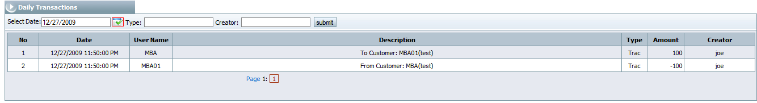
- Solution:
- Database
- Class Diagram


